SQL Project : Billing System Database

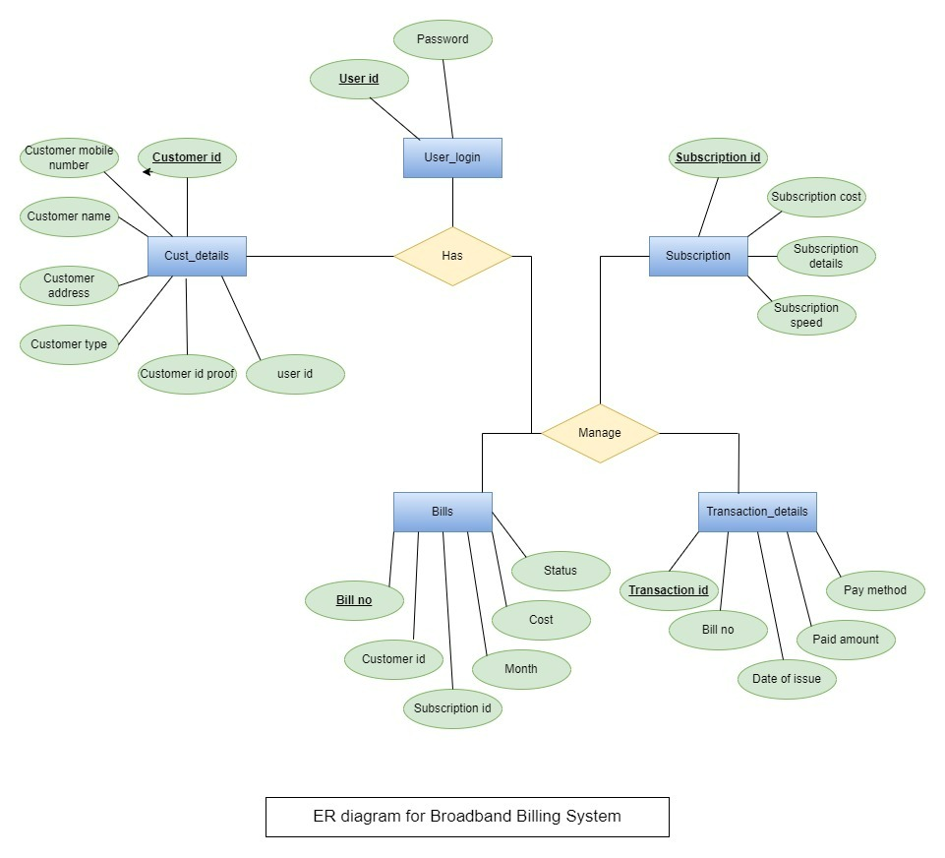

**Data Model Diagram for Billing System:**

[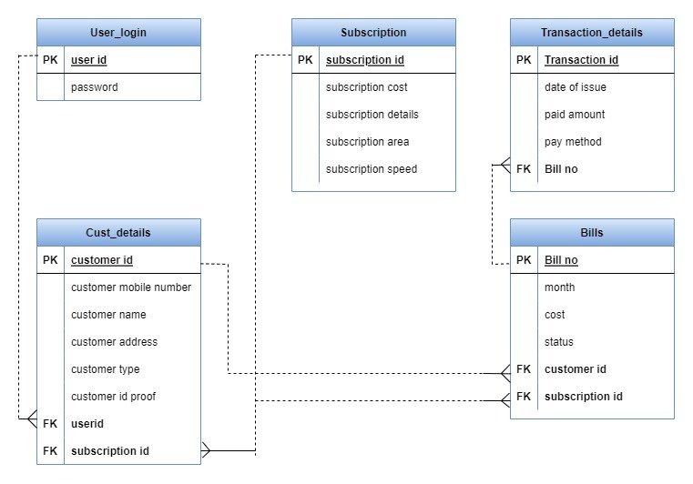](https://1000projects.org/wp-content/uploads/2022/09/Data-Diagram.jpeg)

***Create Data Base:***

1. For this purpose, created a Data base Named “BBS” in the server.
2. Create Objects specified in Data Model & Add data to “Subscription” table
3. Create a procedure that gets customer’s name, customer mobile number, id proof, type, city, area, and password as inputs and registers the customer for choosing any suitable plan of broadband as per his locality.
4. Create a procedure that gets the customer’s name, customer mobile number, id proof, type, city, area, and password as inputs and registers the customer for choosing any suitable plan of broadband as per his locality.
5. Create a procedure that gives the customer all the plans available and the customer can choose anyone plans out of them as per his need and locality by taking subscription id, customer id, and month as input.
6. Create a procedure that will generate the bill for the customer’s chosen subscription plan by taking subscription id, month, and customer id as inputs.
7. Create a procedure to make a transaction for payment for the chosen transaction and will show the transaction details of the customer’s payment status.
8. Create a trigger that gets triggered when there is any update on the bill table after the successful transaction of payment and this trigger has to change the status of bill payment from pending to paid.